Temsah Verilog
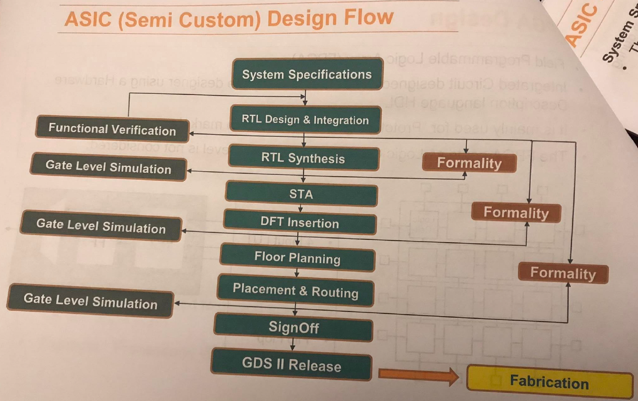
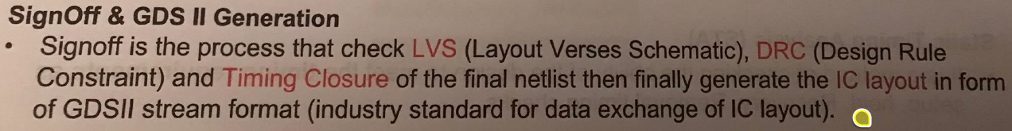
What is the problem with the following code?
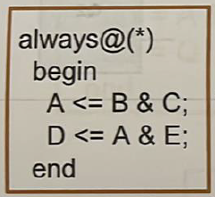
Answer: High chance of simulation-synthesis mismatch. Leeh? La2en bel nesba lel simulation, howa shayef non-blocking assignment, fa howa hay assign el RHS to the LHS at the end of the block. Thus, the simulation behavior will be:
A_next = B & C
D_next = A_old & C
That is, the simulator will use the old value of A while evaluating D. Nroo7 lel synthesis tool. Tyb howa ezay nesta5dem "A_old" de, mesh da keda ma3nah en lazem neb2a me5azenenha aslan? Yes, bs fi nafs el wa2t el synthesis tool hategy tbos hena hatla2y en de combinational always block, fa mayenfa3sh te infer flip flop, w fi nafs el wa2t mafeesh incomplete assignment 7asel, fa mayenfa3sh te infer latch. Tab omal hate3mel eh? 5alas hat behave as if blocking assignments were used, y3ny:
A_new = B & C
D_new = A_new & E
Hence, simulation-synthesis mismatch occurs.
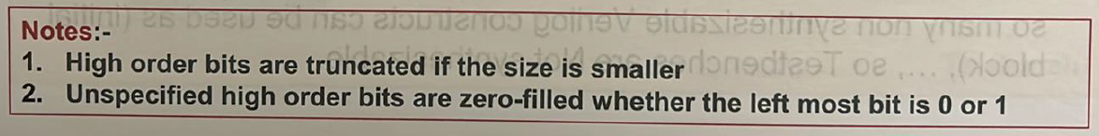
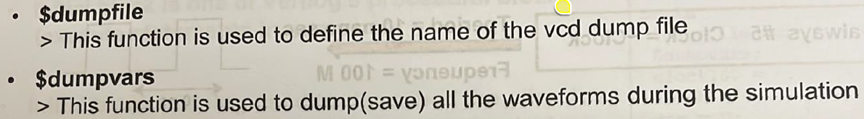
How can we generate a clock in the testbench?
always begin
#(CLK_PERIOD / 2.0) clk_tb = ~clk_tb;
end
How can a Verilog code be for an encoder?
Using a case statement
How can a Verilog code be for a decoder?
Using a case statement
How can we check parity?
Even parity means the number of ones is even, while odd parity means the number of ones is odd. Since the output of an XOR gate is 1 when the number of input ones is odd, an XOR gate checks (or generates) odd parity.
What is the difference between $display and $monitor?
We need to call $display every time to track a variable value. On the other hand, $monitor can be called only once and it will print the values of the variables every time they change.

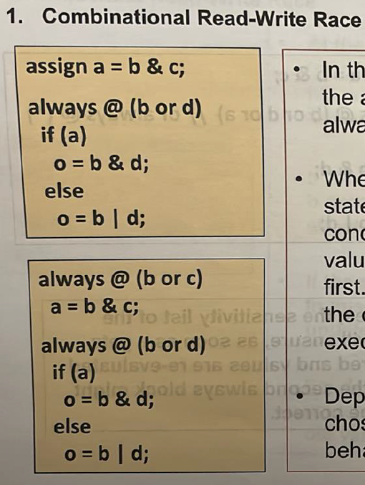
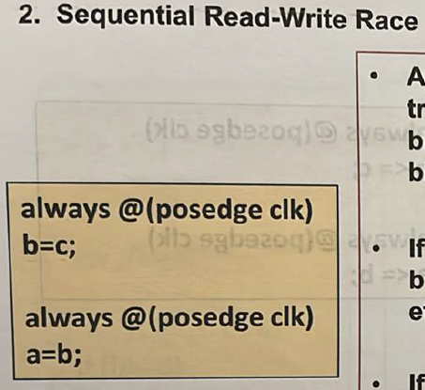
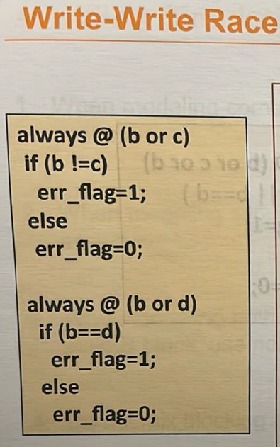
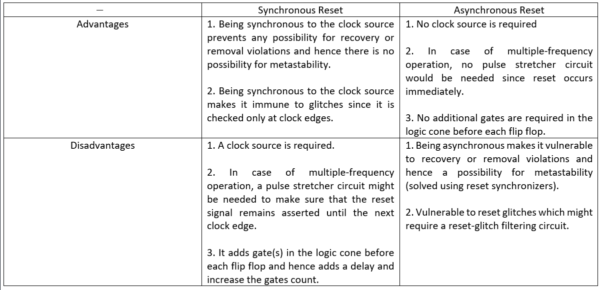
Compare Mealy and Moore in terms of latency and timing robustness.
- Latency: Moore can have more states because the outputs in Mealy react directly to inputs, so no need for wait states. For example, in Mealy, if we want the output to be high for a single cycle, we can simply raise it during the transition from the last state to the IDLE state. However, in a Moore machine, we would need to add an extra state for the output to be raised high in before transitioning to the IDLE state.
- Timing robustness: since Mealy's output can glitch, it has less timing robustness compared to Moore whose outputs are registered.
Which encoding to choose: binary, gray, or one-hot state encoding?
- One-hot state encoding trades off area and power for speed. It does so by using more state FFs (specifically, one FF per state) which simplifies the next-state logic and hence makes the circuit faster. So, for high-speed applications one-hot state encoding.
- If area and power are more important than speed, then it can’t be one-hot state encoding that uses more state FFs and hence more area and power. So, it’s either binary or gray encoding. Which one to choose? Area wise, both have the same number of state FFs ($\log_{2}\left(N\right)$ bits) as well as almost the same next-state logic. So, area wise, they are the same. Power wise, gray encoding can reduce switching power when states are traversed in order. So, power wise, gray encoding might be better than binary encoding or at worst the same. Thus, it makes sense to always use gray encoding and never use binary encoding whenever area and power are more important than speed.

Dr. Kareem Course 1
In a CMOS inverter, what is the forbidden region? Why is it forbidden?
- The forbidden region is the region in which both NMOS and PMOS are in the saturation region. It is called forbidden because it is of a very high gain (slope) which makes it sensitive to noise. This region is a favorable region for analog designers but not digital designers.
- $τ=RC=R\left(C_{int}+C_{ext}\right)=RC_{int}+RC_{ext}$. Thus, increasing the width of a gate doesn’t change its intrinsic delay, but it decreases the extrinsic delay. Accordingly, the gate’s overall delay decreases. However, this increases the delay of the gate before.
- For a PMOS to have the same resistance as an NMOS, it should have double the size.

Temsah STA
- What is the difference between propagation and contamination delays?
  - Minimum propagation delay: the minimum time the output of a gate is guaranteed to be the correct value in the best‑case scenario when charging/discharging happens through the smallest resistance path → not important.
  - Maximum propagation delay: the maximum time the output of a gate is guaranteed to be the correct value in the worst-case scenario when charging/discharging happens through the largest resistance → used in setup analysis.
  - Contamination delay: the minimum time the output of a gate can begin changing, but this does not mean it has reached its final value (it can glitch) → used in hold analysis.
- What is meant by minimum pulse width?
  - A constraint set by the fab/foundry in the technology library (.lib) on the clock and asynchronous set/reset pins of a flip flop.
- Where in the ASIC flow is the minimum pulse width checked?
  - It is checked during STA. The most accurate part of the flow to do so is post-CTS and post-routing because the clock as well as the asynchronous set/reset signals will have taken their final tree and routes.
- How can we fix a setup violation?
  - The setup equation is: $t_{arrival}<t_{req}$. So, to fix a setup violation, we should either decrease the arrival time or increase the required time as follows:
    - $t_{arrival}=t_{cq}+t_{pd}$:
      - $t_{cq}:$ defined by the technology; not something to play with.
      - $t_{pd}$: can be decreased using one of the following techniques:
        - Pipelining.
        - Retiming.
        - Lower combinational gates delay ($τ∝RC$) by one of the following methods:
          - Increase driving strength (i.e. width) which would decrease extrinsic delay but not intrinsic delay. However, this would increase the load on the previous gate, so logical delay effort equation should be applied.
          - lowering the resistance ($R∝\frac{1}{I}=\frac{1}{\frac{K}{2}{\left(V_{DD}-V_{th}\right)}^{2}}$) by either increasing $V_{DD}$ (backend, rarely possible because it requires a different library unless you have multi-voltage domains) or decreasing $V_{th}$ (backend, possible if the library has multiple threshold voltage flavors).
    - $t_{req}=t_{clk}-t_{su}+t_{skew}$:
      - $t_{clk}$: spec, rarely acceptable to play with (unless you can scale frequency in some relaxed blocks).
      - $t_{su}$: defined by the technology; not something to play with.
      - $t_{skew}$: apply positive skew.
- How can we fix a hold violation?
  - The hold equation is: $t_{arrival}>t_{req}$. So, to fix a hold violation, we should either increase the arrival time or decrease the required time as follows:
    - $t_{arrival}=t_{cq}+t_{pd}$:
      - $t_{cq}:$ defined by the technology; not something to play with.
      - $t_{pd}$: can be increased using one of the following techniques:
        - Buffering.
        - Higher combinational gates delay ($τ∝RC$) by one of the following methods:
          - Increasing the resistance ($R∝\frac{1}{I}=\frac{1}{\frac{K}{2}{\left(V_{DD}-V_{th}\right)}^{2}}$) by either decreasing $V_{DD}$ (backend, rarely possible because it requires a different library unless you have multi-voltage domains) or increasing $V_{th}$ (backend, possible if the library has multiple threshold voltage flavors).
    - $t_{req}=t_{h}+t_{skew}$:
      - $t_{h}$: defined by the technology; not something to play with.
      - $t_{skew}$: apply negative skew.

Dr. Kareem Course 2

Wires
- The wire model is as shown below:
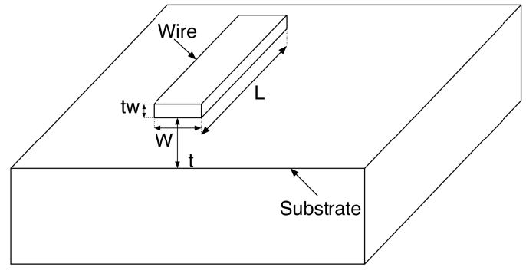
- $τ_{wire}∝RC=\frac{ρL}{A}×\frac{ϵA}{d}=\frac{ρL}{Wt_{w}}×\frac{ϵWL}{t}=\frac{ρϵL^{2}}{t_{w}t}∴τ_{wire}∝\frac{L^{2}}{t_{w}t}$
- As technology advances, transistors become smaller, hence they become closer to each other, which means local wires become shorter. But does this mean their delay become smaller? No, because all other dimensions scale down as well, hence $τ_{wire}∝\frac{{\left(\frac{L}{k}\right)}^{2}}{\frac{t_{w}}{k}.\frac{t}{k}}=\frac{L^{2}}{t_{w}t}$, which means the delay of local wires remains constant as technology advances.
- As technology advances, chips become larger, which means global wires become longer, hence $τ_{wire}∝\frac{{\left(k_{w}L\right)}^{2}}{\frac{t_{w}}{k}.\frac{t}{k}}=k^{2}k_{w}^{2}.\frac{L^{2}}{t_{w}t}$, which means the delay of global wires increases dramatically as technology advances.
- Accordingly, wires delay became the significant source in advanced chips:
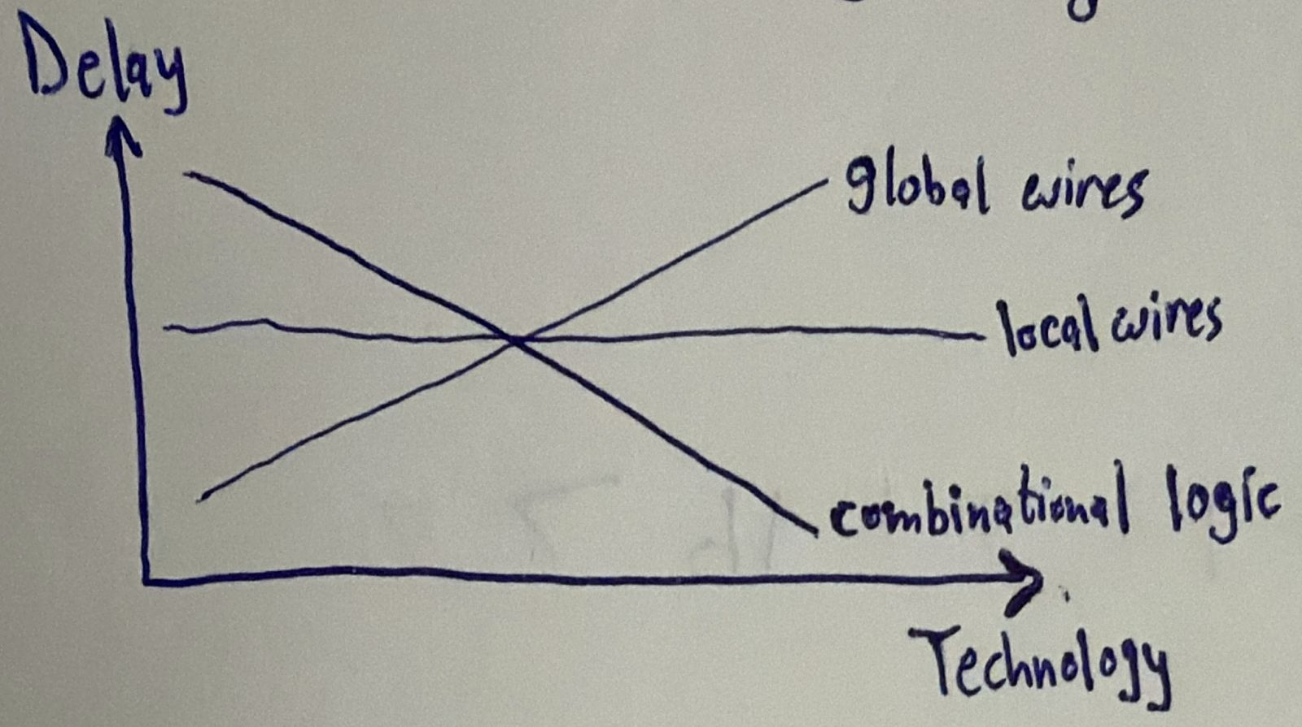
- One way to mitigate the global wires delay is to increase the wires thickness $t_{w}$. However, increasing the wires thickness $t_{w}$ leads to the increase of a type of capacitance called interwire capacitance that causes crosstalk between adjacent wires. To decrease interwire capacitance, adjacent wires have to be farther separated. This leads to hierarchical routing:
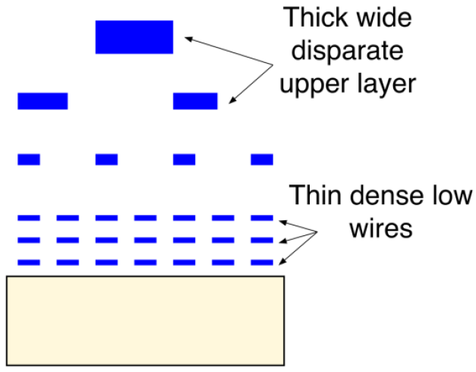
- Wires in higher metal layers are made thicker to decrease the delay, but to avoid the increase of interwire capacitance, they are farther separated. Hence, wires in higher metal layers are used for global routing, while wires in lower metal layers are used for local routing.

Clock
What is “clock skew”?
- It is the difference in the arrival time of the clock between flip flops resulting from different propagation delays from the chip clock pin to different flip flops.
Describe the nature of clock skew.
- Clock skew is deterministic and spatial. Deterministic because once all flip flops are placed, CTS is built, and clock is routed to all flops, we know the skew between two flip flops. Spatial because clock skew is function of space; changing the location of two flip flops relative to each other can change the clock skew between them.
What is clock jitter?
- It is the deviation of the clock edges from the ideal timing (e.g. $T_{s}+δ$ instead of $T_{s}$) due to phase noise in oscillators.
Describe the nature of clock jitter.
- Clock jitter is stochastic and temporal. Stochastic because it is random (normally distributed), and temporal because it changes from time to time.
How does clock jitter affect hold analysis?
- Clock jitter has no effect on hold analysis because hold analysis is done on a single clock edge, so even if jitter moved the edge, it moves it simultaneously at all registers.

Clock Domain Crossing (CDC)
Assume two clocks of the same frequency 50 MHz are generated from two different clock sources. Are they synchronous?
- No, the two clocks are asynchronous because each clock source can have its own initial random settling time, which would cause them to have a non-constant phase relationship.
How would the output of a flip flop behave in case it became metastable?
- Scenario 1: lw enta ghayart el input orayeb awy men el clock edge, fa el flip flop mesh hayshoof el taghyeer da w hayezhar fel clock cycle el bad3eha.
- Scenario 2: lw enta ghayart el input fel nos mabeen el setup time wel clock edge, fa el output hy glitch, y3ny hayro7 lel output bta3 el input el geded w yerga3 tany, wel output el sa7 da hayezhar el clock cycle el ba3deha.
- Scenario 3: lw enta ghayart el input b3d el setup time 3la tool, fa el output el sa7 hayezhar fi nafs el clock cycle bs b3d wa2t atwal men el expected el howa $t_{cq}$.
These 3 scenarios apply to hold time as well, kol el far2 eno b3d el edge badal ablo.
What issue can arise from a metastable flip flop having a larger $t_{cq}$?
- This could cause the propagation of different values at the same time:
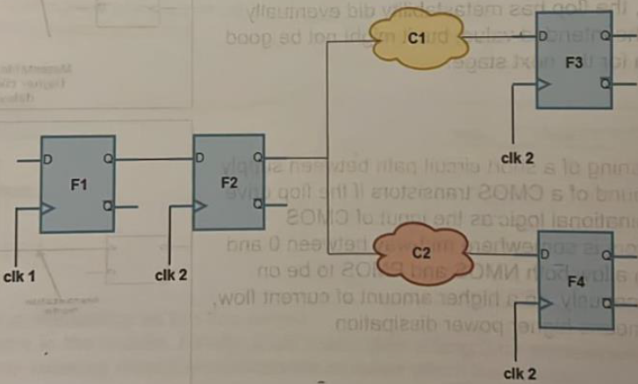
What uncertainty does a double-flop synchronizer have?
- It has a one-cycle uncertainty; the output of a double-flop synchronizer can be ready after 2 or 3 cycles depending on when the first flop got out of metastability.
What does a Gray synchronizer guarantee?
- It guarantees that no garbage data would ever appear on the bus (like what would happen with using multiple double-flop synchronizers with a bus); only either the old value or the new value.
Describe handshaking synchronization
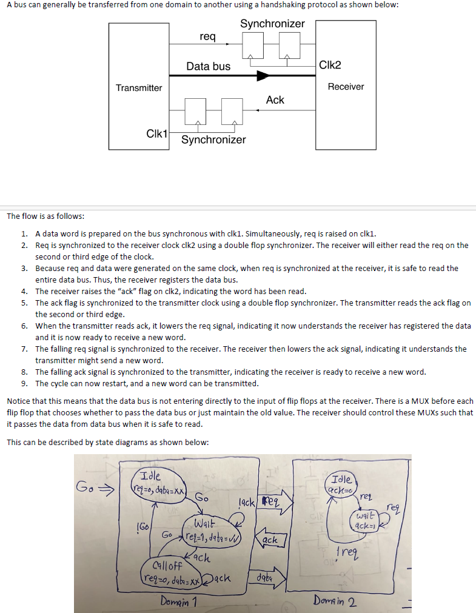
Calculate the FIFO depth for the following example:
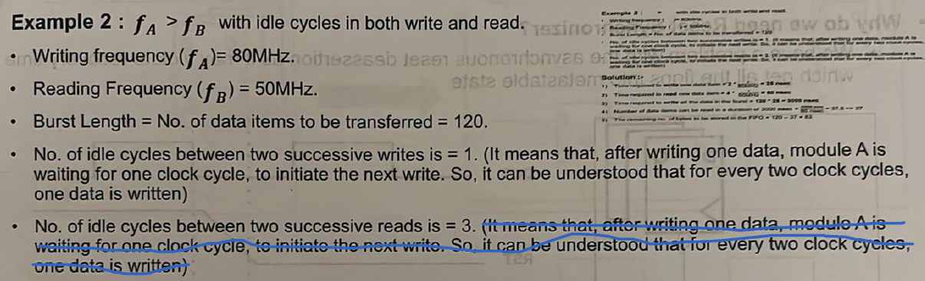
In general, what should the depth $D$ of an asynchronous FIFO be for a Tx write rate of $f_{A}$, Rx read rate of $f_{B}$, Tx idle write cycles $i_{A}$, Rx idle read cycles $i_{B}$, and data burst of $L$ words?
- Lw el Rx mesh beye2ra haga 5ales, yeb2a $D=L$.
- Bs el Rx beye2ra athna2 ma el Tx beyekteb. 5alas yeb2a nsheel men el depth el goz2 el howa 2arah. Tab howa 2ara 2ad eh? 7asab el ratio mabeen $f_{B}$ w $f_{A}$. Yeb2a $D=L-\frac{f_{B}}{f_{A}}L=\left(1-\frac{f_{B}}{f_{A}}\right)L$.
- Tab wel idle cycles? El idle cycles heya ka2en bzbt el rate bta3 el Tx wel Rx got divided by the number of idle of cycles + 1. Y3ny keda $D=L-\frac{f_{B}}{f_{A}}L=\left(1-\frac{f_{B}/(i_{B}+1)}{f_{A}/\left(i_{A}+1\right)}\right)L$.
- N7ot ceiling bs 3ashan lw tele3 fractional:
$$D=ceil\left[\left(1-\frac{f_{B}/(i_{B}+1)}{f_{A}/\left(i_{A}+1\right)}\right)L\right]$$

Temsah Synthesis
What is the set_clock_latency constraint used for?
- It is used to define either source latency (set_clock_latency -source 5 [get_clocks sys_clk]) or network latency (set_clock_latency 5 [get_clocks sys_clk]). Source latency models the delay from the clock source (e.g. PLL or external clock) to the clock definition point, while network latency models the delay from the clock definition point to the clock pins of the flip-flops.
What is the importance of source latency versus network latency?
- Source latency represents the delay from the clock source to the clock definition point. In a single‑clock design with purely internal register‑to‑register paths, source latency usually does not affect timing, because it shifts the launch and capture clocks equally and therefore cancels out in both setup and hold analysis. However, source latency becomes important in other contexts (e.g. I/O timing or multi‑clock designs). Network latency models the delay from the clock definition point to individual flip‑flop clock pins. Unlike source latency, network latency directly affects the relative clock arrival times between different flops and therefore defines clock skew. This makes network latency particularly important in early STA before clock‑tree synthesis, because it allows the designer to model expected skew and identify potential setup or hold issues before the real clock tree is built.
Is the set_clock_uncertainty constraint used with setup or hold analysis?
- It can be used with both as shown below:
$$set_clock_uncertainty -setup 0.2 [get_clocks clk]$$
$$set_clock_uncertainty -hold 0.05 [get_clocks clk]$$
What is the set_clock_transition constraint used for?
- It is used to define the rise and fall times of the clock.
Does there exist a single .lib library provided by the fab?
- Not necessarily, the fab can provide multiple .lib libraries each for a different PVT corner:
  - SS library (slow-slow process, low V, high temp)
  - TT library (typical-typical process, typical V, typical temp)
  - FF library (fast-fast process, high V, low temp)
The fab can also provide a single .lib library with multiple PVT corners called operating conditions, and we can select a specific operating condition using set_operating_condition constraint.
How can wires be modelled in the synthesis step?
- Using the set_wire_load_model defines a wire load model to estimate the wires’ resistance and capacitance and hence estimate their delay.
How do we tell the synthesis tool not to analyze CDC paths?
- By either using set_false_path for two specific clock domains OR using set_clock_groups in case of many clock domains.
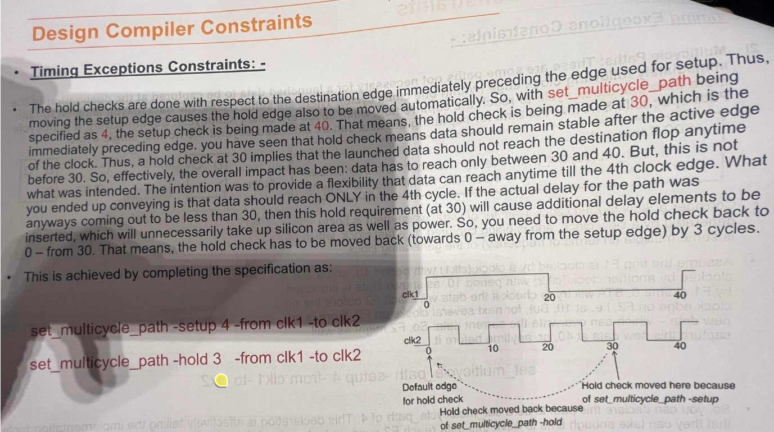

Temsah Power
What are the sources of power consumption?
- Static power:
  - Leakage power:
    - Subthreshold leakage: when $V_{gs}<V_{th}$, the transistor is not just “off”, it is in the subthreshold region where current flows and hence leakage occurs.
    - Gate oxide tunnelling: the oxide layer thickness between the gate and channel scales down, hence at some point it allows gate current and hence leakage occurs.
- Dynamic power:
  - Switching power
  - Short-circuit power: to cancel it, $V_{DD}=2V_{th}$.
  - Glitch power: it is nothing but a mix of switching power and short-circuit power. Due to glitches, the activity factor ($α$) of a signal can exceed 1.
Mention power reduction techniques
- Switching power reduction techniques:
  - Activity factor ($α$):
    - Clock gating.
    - Avoid using XOR gates as much as possible (e.g. comparators).
    - Operand isolation.
    - Use shifters instead of constant multiplications.
  - Load capacitance ($C_{L}$):
    - Gate capacitance: use smaller gates (but need to have a slack).
    - Wire capacitance: do better floor planning, placement, and routing to decrease the wires’ length.
  - Frequency ($f$): multiple frequencies.
  - Supply voltage ($V_{DD}$): multi-voltage domains.
- Short-circuit power reduction techniques:
  - Multi-threshold domains.
- Glitch power reduction techniques:
  - Operand isolation.
- Leakage power reduction techniques:
  - Multi-threshold domains.
  - Power gating.
What is the problem of using an AND gate for clock gating?
- “Pulse clipping” and minimum pulse width violation.
- Setup/hold time violation.
Draw the latch-based clock gating cell.
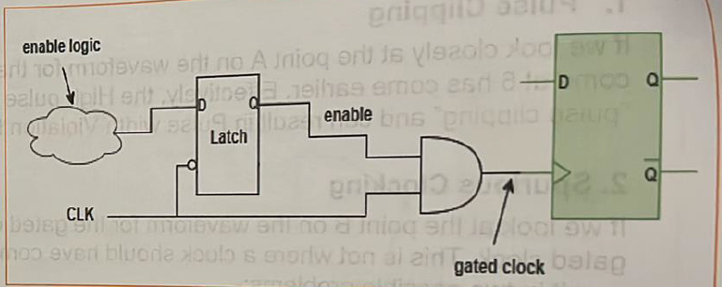
From power point of view, should we increase or decrease $V_{th}$?
How is power gating done?
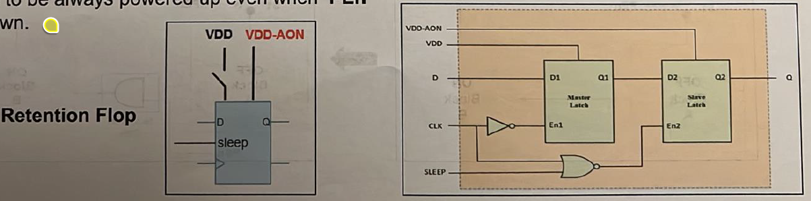
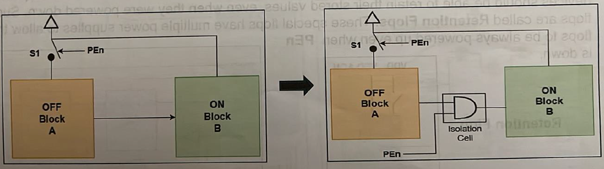

Lint
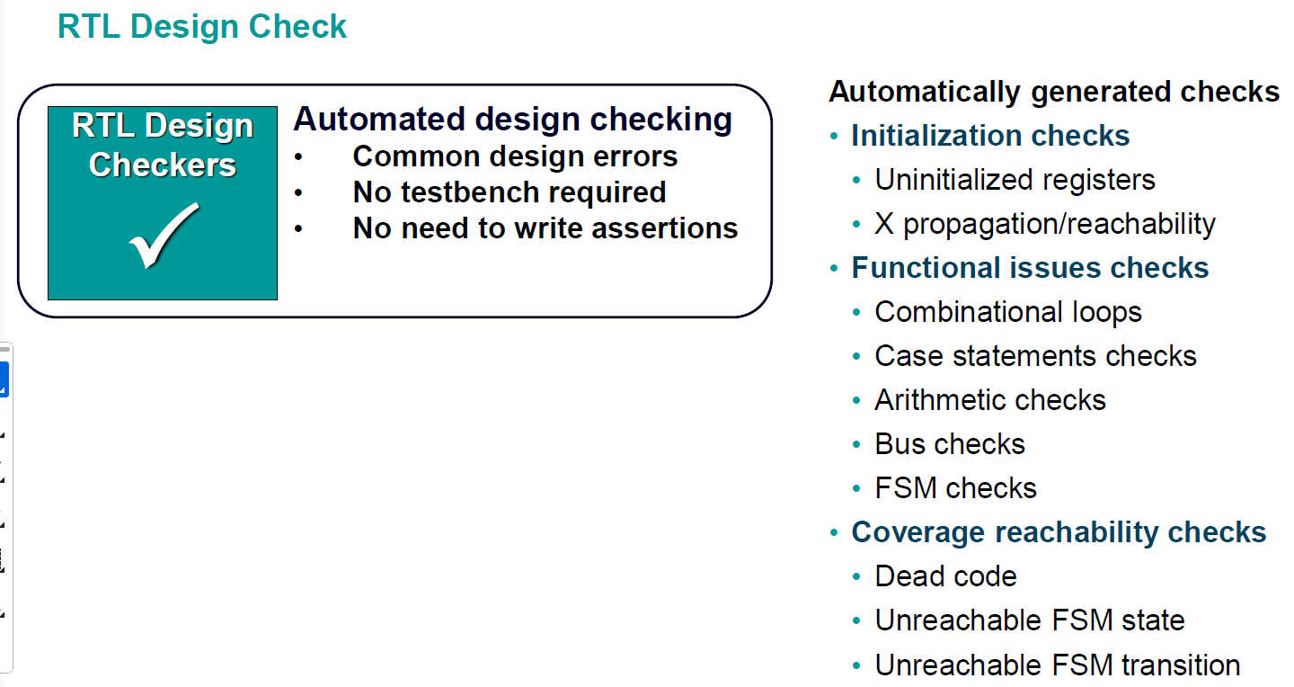

Temsah Formal Verification
How is equivalence checking done?
- You give the formal engine the RTL and a gate-level netlist, and through mathematical transformations and Boolean equations, the tool compares the functional equivalence checking between both. This is done through dividing the design into logic cones and compare points.
What is model checking?
- Da el inputs bta3to mesh RTL w netlist b2a, la2 da el input bta3o RTL w a set of properties/specifications enta 3ayezha tefdal met7a2a2a 3la tool (e.g. SystemVerilog Assertions), w el haye3melo el model-checking engine eno exhaustively hay go through all possible states in your design b7ees ye make sure en el properties de dayman met7a2a2a, w lw la2a case mesh met7a2a2a fiha, hayedelak el set of inputs (i.e. stimulus) el bey5aly property mesh met7a2a2a, which we call a counterexample.

Temsah DFT
What are the possible issues during fabrication/manufacturing?
- Short circuit
- Open circuit
- Stuck-at-1
- Stuck-at-0
How are controllability and observability before and after DFT logic insertion?
- Before DFT, controllability and observability are harder because the nearer a gate is to the input, the easier it is to control its inputs, but the harder it is to observe its output, and the nearer a gate is to the output, the easier it is to observe its output, but the harder it is to control its inputs.
- The DFT logic improves controllability and observability through replacing all flip flops in the design with scan flops. A scan flop is nothing but a normal flip flop with an input multiplexer with a “scan enable” selection line that selects between either the functional path (i.e. the normal design path) and the scan path. This way, we can build a long shift register starting from a scan input port to the chip, which can be used by the ATE tool to pass in the test pattern generated by the ATPG for testing the chip for manufacturing defects.
- Every scan chain has its own Scan Enable (SE) & Scan Input (SI) input ports and Scan Output (SO) output port.
What are the steps of DFT?
- DFT testing consists of 3 steps (check the example below):
  - Shift in: set SE = 1, SI port to the value you want to drive the target node with, and then wait until SI’s value reaches the target node.
  - Capture: once the SI’s value reached the target node, now set SE = 0 to activate the functional path.
  - Shift out: the next clock cycle, set SE = 1 again to shift the captured value to the output of the scan chain.
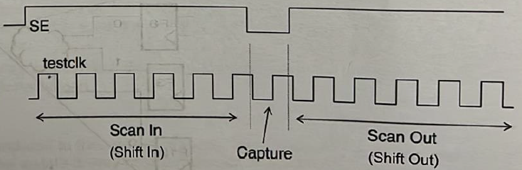
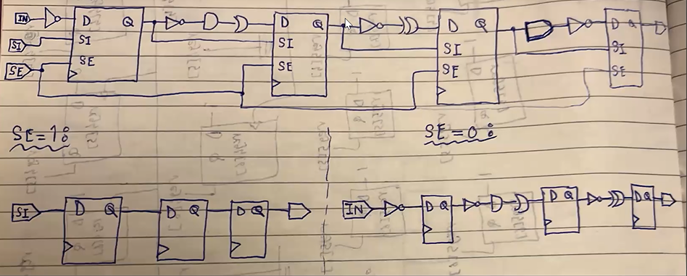
What does the “coverage” number reported by the DFT tool represent?
- It indicates the percentage of nodes the ATPG can activate and observe.
What is the timing overhead of adding the DFT logic?
- The additional multiplexer at the input of each flip flop causes a higher setup requirement on the functional paths.
- Scan flops have higher clock-to-q delay as the flop now drives an additional load, which is the scan-in port of the next flop.
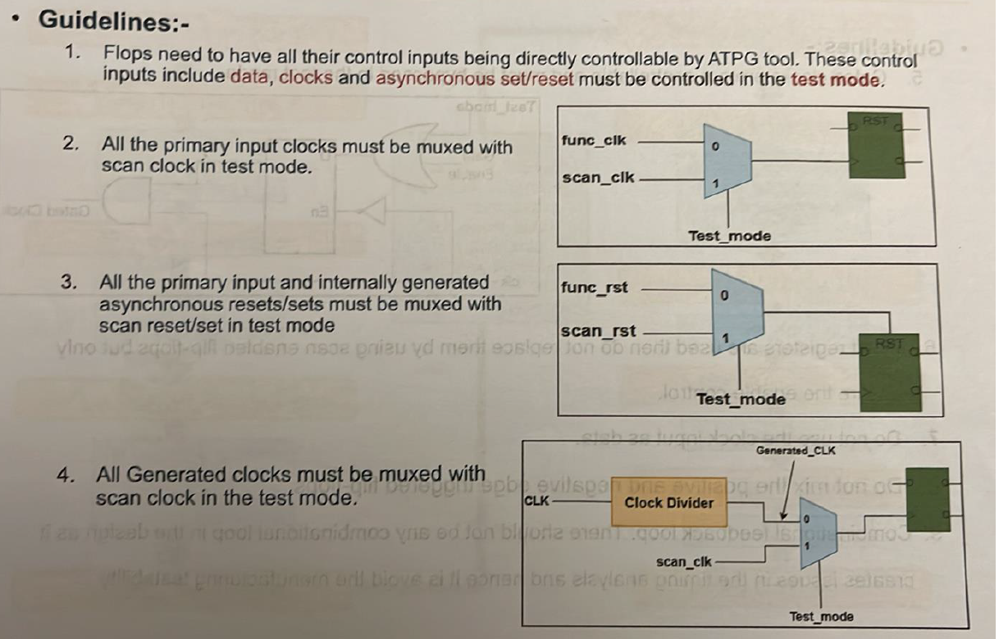
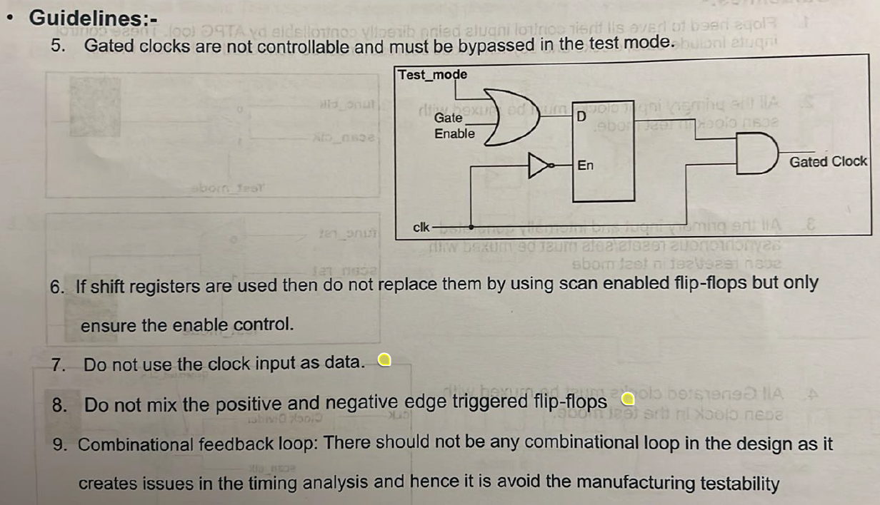

Code/Functional Coverage

Temsah PnR

DSP Design Guide
Nothing worth writing really.

FPGA
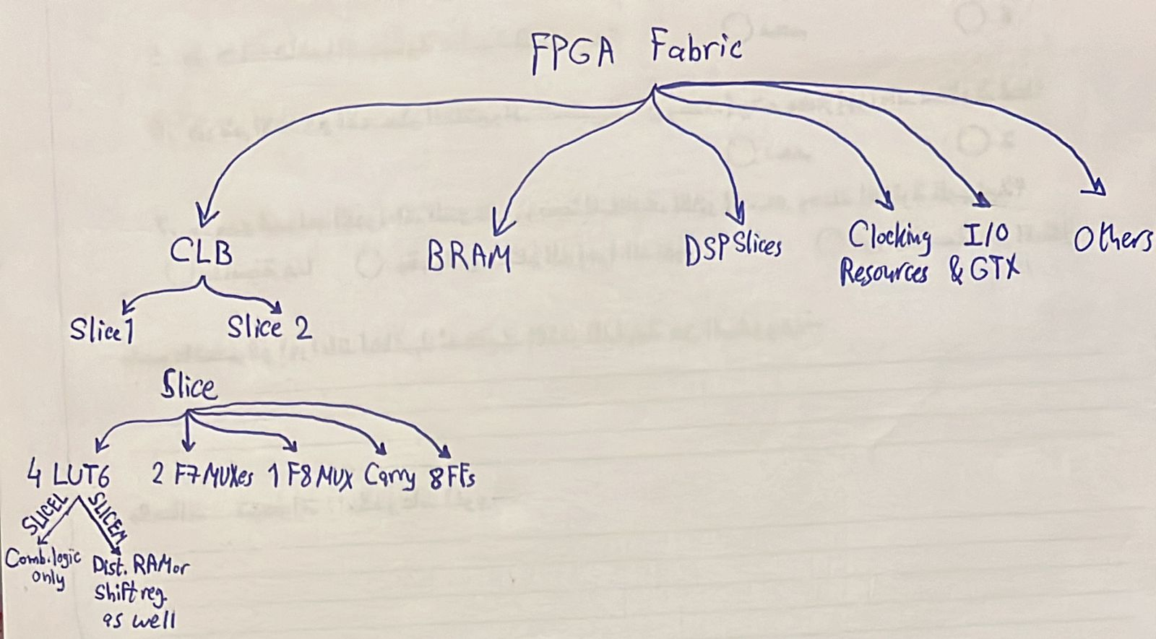

DPD
- The story to tell:
  - Lama bada2na neshtaghal 3leeh makansh lesa leeh customer, da kan aslan mashroo3 ta5arogy. El 7asal en Analog Devices el most profitable product bta3ha howa el power amplifiers. W tab3an el non-linearities bta3t el PAs heya inevitable, fa lazem kan el customers bto3 el PAs bto3na beye3melo their own DPD 3ashan ye linearize our PAs. Fa gat el fekra en tab w leeh mane3melsh e7na el DPD bema enena aktar nas 3arfa el PA la2eno bta3na, fa nzl el DPD ka mashroo3 ta5arog w ana el eshtaghalt 3leeh. 3amalt shoghl kwayes fa they hired me, w kmlt b2a shoghl 3leeh w lesa mfeesh specific customer. W kan el tafkeer howa eno hayeb2a ASIC, fa olna 5aleny anazelo el awel 3la FPGA w lama teb2a el denya tamam nebda2 netalla3o fi test cell ka ASIC. W f3ln bada2t ashtaghal 3al asas da w I deployed it 3la FPGA Zedboard, bs tab3an de FPGA da3efa, fa kanet el clock frequencies el ba2dar awsalaha mesh bet3ady el 350 MHz, we7na kona 3ayzeen aktar men keda bekteer. Fa 3amalt comparative study sa3et-ha maben el Zedboard w board tanya mawgooda heya el Zynq Ultrascale+ ZCU104 w I showed en ne2dar newsal le almost 900 MHz 3la el Ultrascale+. Fa gat el FPGA w nazelt 3leeha el DPD w I tested el kalam da fel lab w kan kol haga tamam. L7d hena makansh fih customer lel DPD specifically.
  - B3d keda geh customer kona already bene3melo chip fiha power amplifier, fa kan interested el DPD efforts el 3amaltaha, bs makansh fih area kafya 3al chip enena nenazelo ka ASIC, fa fakkarna f 7al w howa en el chip kan already 3leeha processor ARM Cortex-M0, fa why not nenazelo just ka software w neb2a keda ma5adnash area wala haga. Bs again el challenge kan en M0 da da3eef wel DPD me7tag frequency 3alya, fa I made another comparative study been M0 w M85 w I proved en ne2dar ne meet el specs using M85. W da 7aleyan el e7na shaghaleen 3leeh, how to deploy the DPD on ARM Cortex M85. Fa hena ana ba7awel akteb C code lel DPD.
  - Delwa2ty b2a el kalam ma3 customer tany eno 7abeb el DPD yeb2a ASIC, w bel taly bada2na nefakkar enena nenazel el DPD RTL el ana 3amalto abl keda 3al FPGA kolo ka test cell, y3ny ASIC, w ta7dedan 3la technology 22FDX bta3t GlobalFoundaries, de actually el e7na mtalla3en 3leeha a5er two chips eshtaghalna 3leehom. Bs m2agelen da shwaya bs 3ashan el seka el tanya bta3t el C el tapeout bta3ha 2arrab w leha higher priority. Fa el mafrood el goal b3d ma a5allaso ka C code eny abda2 fih ASIC, wel ana already 2ata3t fih shoot kbeer sa3et el FPGA.

Dr. Kareem Book
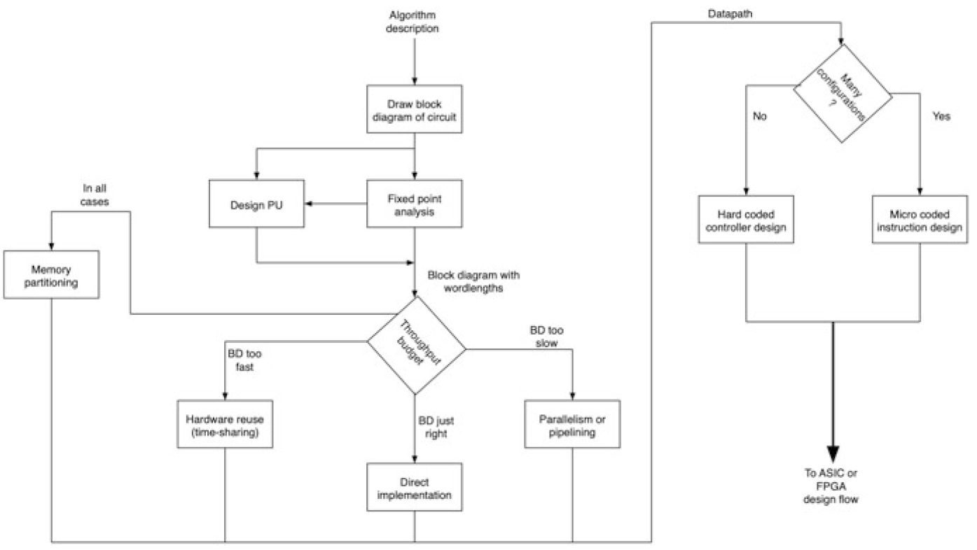

SystemVerilog

Others
- From ADI’s internship interview timing question: always mix max and min delays during analysis 3ady to design for the worst case scenario. Even STA tools do this because, in reality, even on a single FF or SS chip, one path can behave “fast” while another behaves “slow.” Fa el sa7 enena ne mix el min wel max delays 3ady.
Where does the clock come from?
- The clock originates from a reference oscillator, typically a crystal oscillator. This reference clock is fed into a PLL, which synthesizes the internal clocks used by the digital logic by multiplying, dividing, and conditioning the frequency. So:
Oscillator → Ref Clock (e.g. 25 MHz) → PLL → High-Speed Clock (e.g. 1.9 GHz)
Write down 3-bit and 4-bit Gray counts
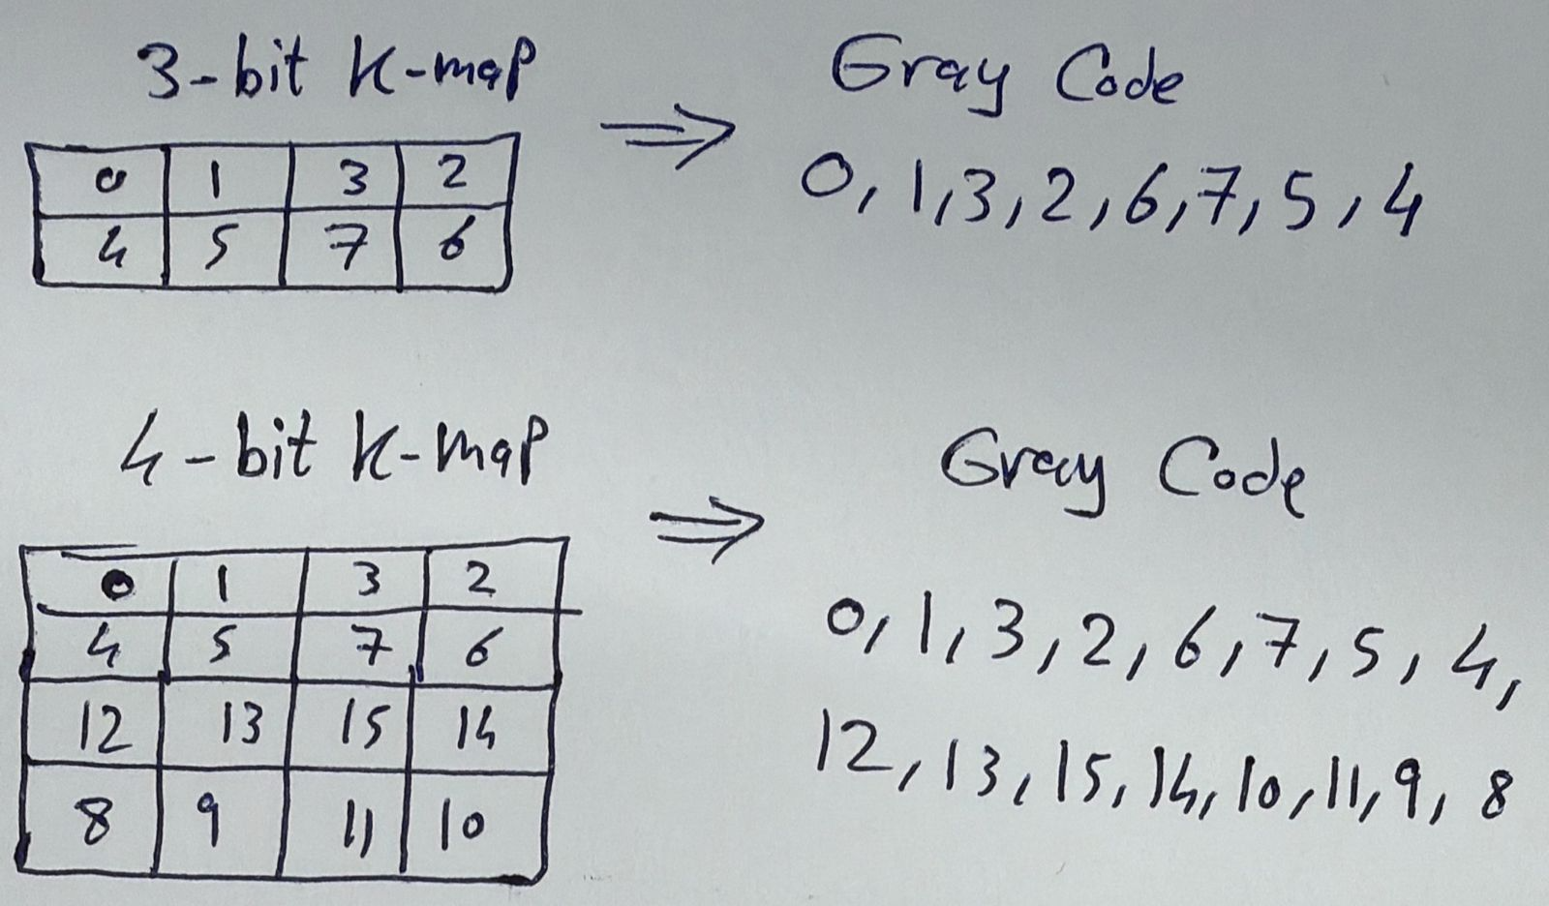

Interview Questions
“Why did you prototype your DPD design on FPGA first when the target is ASIC?”
- “Because FPGA is a smart way to de-risk an algorithm or a hardware architecture before committing to ASIC. Prototyping on an FPGA can validate real-time behavior end-to-end at near-deployment rates. This is important because ASIC is expensive and slow to iterate, and FPGA can de-risk this”.
“If you verified extensively in simulation, why prototype on FPGA?”
- “Because simulation checks correctness; FPGA checks deployability, like real-time behavior and fixed-point stability. So, the FPGA step isn’t redundant — it’s important to de-risk things that simulation can miss”.
“You must have simulated many test cases, which ones do you choose for FPGA prototyping? Why those test cases specifically?”
- “We agree we can never prototype all test cases we simulated on the simulator because we would spend ages in the lab doing so, right? So, we have to pick scenarios that can hit multiple test cases at once, and the choice here depends greatly on the system under test. In case of the DPD, for example, I prioritized the scenarios with high output power from the PA because they represent the worst-case operating conditions. In this region, nonlinear effects are strongest, coefficient magnitudes are largest, and the design is most stressed. A design that is stable and convergent under these conditions will almost always survive under more relaxed conditions”.
“What was the target clock frequency of the DPD project?”
- “The target clock frequency for the ASIC implementation was around 1.9 GHz, but during FPGA prototyping FPGA, I only reached 800 MHz”.
“Why was the target frequency on the FPGA different from that on ASIC?”
- “Because FPGA and ASIC have fundamentally different implementation fabrics.
On FPGA, achievable frequency is often limited by programmable LUTs and routing matrices, which are generic structures and introduce significant routing overhead. These are not optimized for a specific design.
In contrast, an ASIC implementation uses standard-cell logic and optimized interconnect, which allows the datapath to be tailored very precisely to the design and therefore achieve higher clock frequencies.
For the FPGA prototype, my goal was not to match the ASIC target frequency directly, but to prototype the design in a real-time environment at near-deployment rates. Accordingly, I managed to achieve a clock frequency of about 800 MHz, while the ASIC target frequency was around 1.9 GHz.”
“How did you synthesize the multipliers in the DPD?”
- “That’s a good question because when I synthesized the design on the FPGA, I made sure multipliers are mapped into DSP slices for optimum performance. So, speaking with the implementation Engineer back then who worked on the ASIC backend flow of the DPD, we decided to first give the synthesis tool the multipliers in the design as-is (i.e. keep the asterisk ‘*’ operator in the RTL), and if it happened that we are not meeting timing, area, or power constraints, we would have figured out our own multiplier algorithm and architecture, but all specs were already met using normal ‘*’ operator”.
“Why don’t we use latches in design?”
- “Data has only $\frac{T_{clk}}{2}$ to propagate from one latch to another, while flip flops allow data to propagate in $T_{clk}-t_{su}$.
  - Being level triggered, latches are vulnerable to glitches.
  - Place and route tools find it harder to achieve timing closure in latch-based designs. Watch this from 5:20 to the end.”

